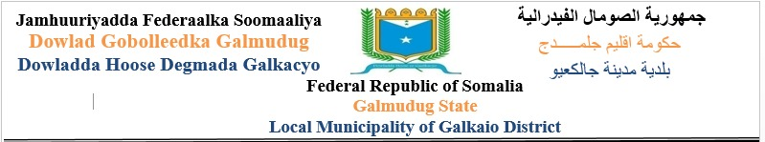

Date: 27/12/2021

MUDO KORDHIN BAAHIN QANDARAAS

REF: GLK/GMS/LDF/JPLG/001/2021

Maamulka Degmada Galkacayo Ee Dawlada Galmudug, waxa ay Sanadka 2021 kaheshay maalgelinta Mashruuca Dawladaha Hoose Ee Adeega iyo Maamul-daadejinta (JPLG), waxa ayna doonaysa in maalgellintaa ay u isticimaasho mashaaruucyo horumarineed. Sidaas darteed, Golaha Deegaanka Degmada Galkacayo waxa ay naadinayaan shirkado qandaraasleyaal ah oo kuhaboon in ay qabtaan shaqada hoos ku qoran.

SN | Project No. | Project Name | Location
1. | GLK/GMS/LDF/JPLG/001/2021 | Galol & Hobyo Tarmac Road | Gaalkacyo, Galmudug

Documentiga qandaraaska waxa laga helayaa ama laga Qaadanayaa Xarunta Dawlada Hoose Ee Gaalkacayo laga billaabo taariikhda: 27/12/2021 ilaa 18/01/2022. qiime ahaana waa $20 qandaraaskiiba.
Qandaraaslihii soo doonta waxa loo jaridoonaa rasiidh. Qandaraaslayaashu waa in ay ku soo lifaaqaan rasiidhkaas codsiga qandaraaska.

Qandaraaska dokumintigiisa waa in loo soo diyaariyaa iyadoo la raacayo tilmaamaha la siiyey qandaraaslayaasha iyo qoraallada kale ee qoraalkan kuxusan.

Qandaraaska waa in lagu soo gudbiyaa seddex nuqul, waana in lagu soo hagaajiyaa:

XAFIISKA QANDARASYADA DAWLADA HOOSE Ee Galkacayo Ee Dawlada Galmudug

Wixii Faahfaahin Dheerada fadlan kala xidhiidha Ciwaanada Hoos Ku Xusan

Email: Galkacyo.mayor@gmail.com ama Warsamefarah114@gmail.com

Document gaqandaraaska waxa la soo xaraynayaa Kahor wakhtiga; 12:00pm Duhurnimo, taariikhda; 18/01/2022.

Qandaraaslayaasha waxa loogu yeedhayaa inay yimaadaan shirqandaraas, 6 cisho ka dib maalintaqandaraaska la naadiyo, taariikhda; 25/01/2022, waqtiga; 09:00 subaxnimo, Goobta; hoolka shirar ka ee dawlada hoose si loogu sharxo wixii faahfaahin ah ee ay uga baahan yihiin qoraalka qandaraaska haday jiraan.

MAHADSANIDIIN
Waxyaabaha loo baahanyahay in lagu soo lifaaqo Qandaraaska;
No | Type | Description |  |  | Submitted
 |  |  |  |  | Yes | No
1 | Certificate of Registration | From Gaalkacyo District
2 | Licence of the Company | From Ministry of Public Works of Galmudug
3 | Receipt from District | Bid documents from Source | $ | 20)
 | Council for bidding
4 | Certificate of completion | The past three years completed projects with
 | projects | UN agencies, INGOs, Government etc.
5 | CVs of project engineer | The project engineer’s CV
 | with certificate
6 | The company’s profile | The company profile documents
7 | Bid fully priced | Priced BOQ, the bidding document (amount in
 |  | figures and amount in words)
8 | Bid signing | To sign and to stamp (Signed form of tender))
9 | Updated Bank | Supplier provides Bank statement for last one
 | Statement | Year period?

