CONSULTANCY TERMS OF REFERENCE
HYDRO-GEOPHYSICAL SURVEY IN Cadmadooni village, (BORAMA DISTRICT, AWDAL REGION, SOMALILAND)

- BACKGROUND
Concern Worldwide is a non-governmental, international, humanitarian organization dedicated to the reduction of suffering and working towards the ultimate elimination of extreme poverty in the world’s poorest countries. Concern engages in long-term development work, responds to emergency situations, and seeks to address the root causes of poverty through development, education and advocacy work.

- PURPOSE OF CONSULTANCY SERVICE
Concern through funding from Irish Aid plans to drill a borehole and construct associated infrastructure aimed at providing safe sustainable drinking water. The purpose of this consultancy is to conduct a comprehensive hydrogeological and geophysical survey and related assessments in the pre-selected village and surroundings for exploring groundwater sources to improve access to safe and sufficient water availability for human consumption and livestock use.

- OBJECTIVES
Conduct hydro geological surveys in one village located in Borama district in Awdal region and the surrounding, to establish the most suitable location of permeable deposits that would be storing adequate amounts of potable water to be exploited through a drilled borehole. The study should clearly recommend the anticipated maximum depth of drilling and description of aquifer types.

Carry out Environmental Impact Assessment (EIA) for the proposed boreholes to ensure that proper planning is done and that likely potential negative impact that might arise from developing the project are identified and that appropriate mitigation and monitoring measures are included in the project design.
- LOCATION
This survey will be conducted in the following location and surrounding areas with potential for groundwater development.

Name of the site | Nº | E
Cadmadooni village | 9.689936° | 43.39792°

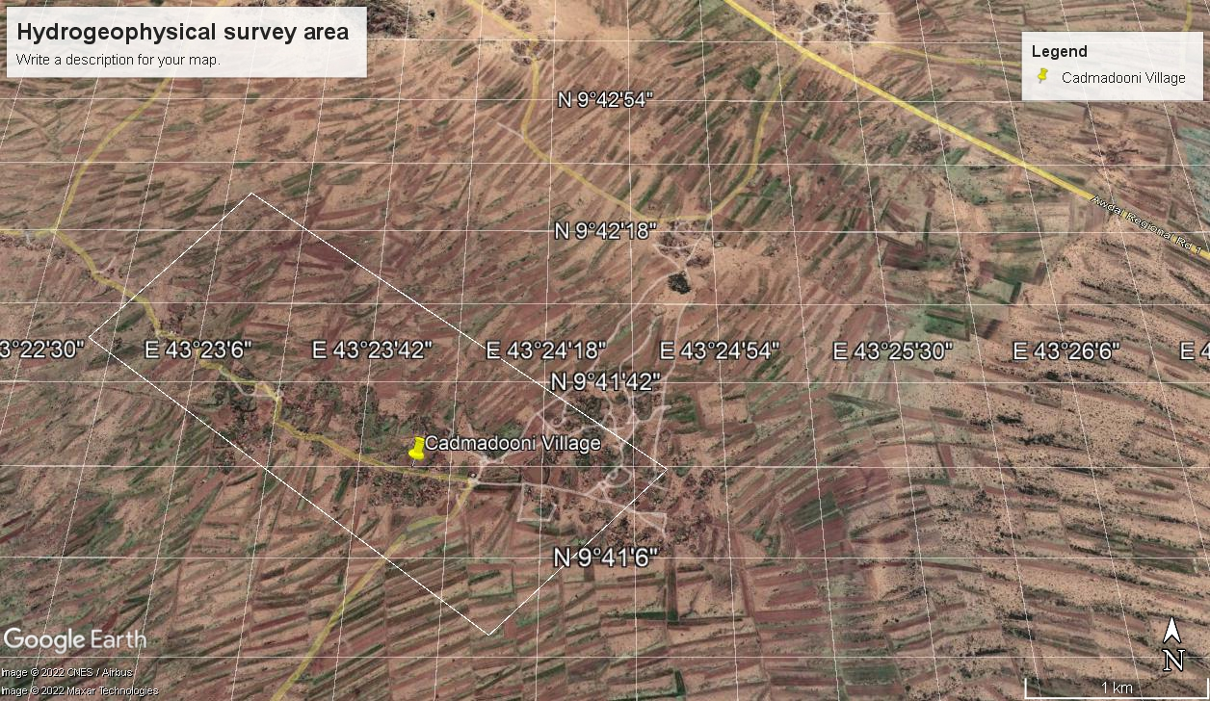
Figure 1: Map showing the proposed survey site.

- METHODOLOGY
The Consultant is to carry out geophysical measurements within the study area using the ABEM Terrameter SAS 1000, which distinguishes between clays and fresh water by use of Induced Polarization (IP) measurements. Furthermore, Werner traverses may be carried out, at different spacing to map out possible buried faults.
The hydrogeological and geophysical investigations will be carried out according to a multi-step approach:
- Desk study and data-acquisition: review of existing data, topographical maps, satellite images (Landsat TM with 30 m resolution), existing studies and borehole site investigations in the area, geological reports and maps (if available), borehole and surface water records, etc. This should be done in coordination with the ministry of water Resoruces.
- Hydrogeological fieldwork: detailed reconnaissance survey of project area (GPS co-ordinates, water level measurements, TDS and EC, condition, usage and performance where applicable) inspection of geological, geomorphological and structural characteristics of the investigated area; verification of existing data and findings including the spring water source area.
- Geophysical measurements: resistivity/IP profiling and vertical electrical/IP soundings.
- Analysis of hydrogeological and geophysical data.
- Compilation, analysis, and evaluation of the gathered data and information.
- Site selection and reporting.

  - Expected outputs of the Hydrogeological survey

The expected output of this study shall be a Hydrogeological Investigations report detailing the following:
- Description of the geology and hydrogeology (incl. Inventory of boreholes and other water points) in the area of investigation;
- Methods of investigations employed, including Geophysical Techniques;
- Detailed resistivity/IP survey (Wenner & VES) to delineate the productive aquifer- Consultant to carry out minimum of 500m Werner profiles and 6 VES soundings. Out of the 6 soundings, 2 shall be control soundings –As provided in the GPS coordinates of section 4 in this report;
- Information on the aquifer potential; sustainable yield & water quality;
- Proposed drilling two drilling sites, recommended maximum drilling depths, water strikes levels and aquifer types.
- Proposed drilling method, and its applicability in the project area.
- Mark two drilling site within the village and it’s surrounding with a concrete mark stone in presence of the WES Committees and collect GPS coordinates of the sites and submit the same along with the final survey report.

  - Socio-economic and environmental impact assessment
Conduct an environmental impact assessment for the project which includes;
- Nature of the project and location of project area
- Activities that shall be undertaken during the project construction, operation and decommissioning phase.
- Project design, materials to be used and by-products, and disposal methods.
- Identified environmental impacts of the project (both positive and negative) during the i) drilling and construction phase and ii) the borehole operation phase.
The assessment should consider impacts on:
-Water resources, with specific attention to the impacts of groundwater exploitation on the existing springs in the surroundings of Cadmadooni village.
-Soil/land
-Vegetation
-Land use and grazing management
- Wildlife
- Economical and socio-cultural impacts associated to the potential environmental impacts identified.
- Any other information the authority may require.

- DURATION OF WORKS
The duration of the consultancy will be decided by the consultant in agreement with the WASH and Construction Coordinator but should not exceed 10 days from the date of signing agreement. Proposed work and travel plan will be developed during the consultation meeting above. The consultant will prepare a tentative work plan for the study and include this in their offer. The work plan should set out the timelines of the following activities;
- Acquisition and review of secondary data in the office;
- Assessments/surveys and meetings with line ministry and relevant stakeholders in the field in Borama district;
- Data analysis and reporting.

REPORTING
The consultant shall report to the WASH & Construction Coordinator or his assigned delegate.
The final report will be a comprehensive account of the whole Consultancy service, to professional standard. It will review the existing literature and other relevant information, such as drilling logs, satellite images, etc. The report shall include all field data, interpretations and justifications, hydrogeological evaluations, conclusions and recommendations relating to the investigated area. In addition, appropriate maps, diagrams and data plots shall be presented.
The reports must be prepared in simple and clear English. The draft reports should be submitted within 4 days after completion of the field work. The final reports must be submitted within 3 days of getting feedback from Concern Worldwide. The final reports will be drawn up in 3 copies and submitted also in soft copy (in MS WORD and PDF Formats) to Concern Worldwide for approval. Final payment to the Consultant shall be made upon approval of the final report by Concern Worldwide.
The following report format will be adhered to for the Hydrogeological survey report:
(i) Cover page:
- Title of the study with the logos of Concern Worldwide and the donor
- Consultant’s details: name and contact
- Date of the study and location
(ii) Table of contents
(iii) Executive summary, max 2 pages
- Brief description of the assignment
- Objectives of the consultancy, methodology and duration of the study
- Main findings, conclusions and recommendations
(iv) Main body of the report, max 15 pages.
It will provide comprehensive details of the points listed in the Executive Summary. It will contain a description of the findings and an analysis or interpretation of the data collected. It will include a detailed description of the approach and methodology of the survey/assessment. Conclusions and recommendations should be clear and practical based on the local context.
(v) Annexes
- Terms of Reference;
- Werner profiles and VES Data;
- List of literature and documents consulted;
- List of persons / organizations consulted;
- List of places / sites visited;
- Tools / materials used in the assignment;
- Sketch Maps for all the sites investigated and clear indication of the recommended and an alternative site.
- BOQs and cost estimates for drilling and construction of the borehole which must be quoted in USD.
- Photos taken during the survey with one showing the exact clearly marked site selected for drilling of the borehole. The photos should be taken using GPS camera.

- COST
The consultant is expected to include all costs related to the consultancy including cost of accommodation, food and transport (personnel and equipment) to/from and within the Borama district.
- REQUIREMENTS
- The consultant(s) should have a degree in Hydrogeology/Geophysics;
- The consultant must be registered by a relevant professional governing body;
- The Consultant shall present a list of previous work done in Somaliland or similar hydrogeological set up;
- Possess necessary resources to undertake works of such a magnitude including equipment, personnel vehicles etc. (include list of equipment, CVs of personnel)
- Submit a detailed technical proposal including proposed methodologies, data analysis and interpretation, reports and work schedule;
- Financial proposal quoted in USD with per unit cost for commencing this consultancy work;
- Proven experience on similar tasks and assignments (include work completion certificates);
- Submit one report of similar assignment carried out by the consultant;
- Provide contact details for past 3 clients worked with for reference checks;
- Indicate earliest date of availability to undertake assignment.
Where necessary the engineer consultant-lead will work with other consultants with the technical skills required to perform the above tasks. The detail of the consultant team roles and consultant feed will be presented in the narrative and financial proposal.

- Application process
Qualified and interested independent engineer consultants or consultancy engineering firms are requested to submit the following documents:
- Expression of Interest
- Consultant-lead/Company Profile, including CV and Engineer accreditation, samples of previous sand dams designs and references.
- Where a team of consultants is proposed, to perform the ToR tasks, the consultant team roles will be described in the technical proposal and the CVs and accreditations of all the team members attached to the proposal.
- Technical proposal clearly demonstrating a thorough understanding of this ToR and including, but not limited to, the following:
  - Description of the methodology proposed to achieve the specific objectives of the ToR.
  - Proposed timeframe detailing activities and work plan.
- A financial proposal with a detailed breakdown of costs for the consultancy quoted in United States dollars. (Consultancy fees of the consultant-lead and other consultants will be specified in USD per working day).
Please forward full-applications to: procurement.hargeisa@concern.net CC haron.emukule@concern.net. Subject line: CONSULTANT NAME- Application consultancy: hydro geophysical survey Borama district.
The Submission of technical and financial proposals closes on 21st July 2022.

